Search

Number of selections

Artifacts created

Handle

Click to open

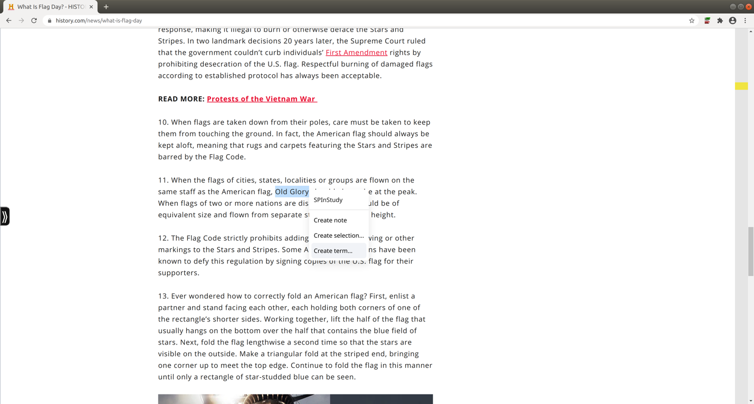

Search

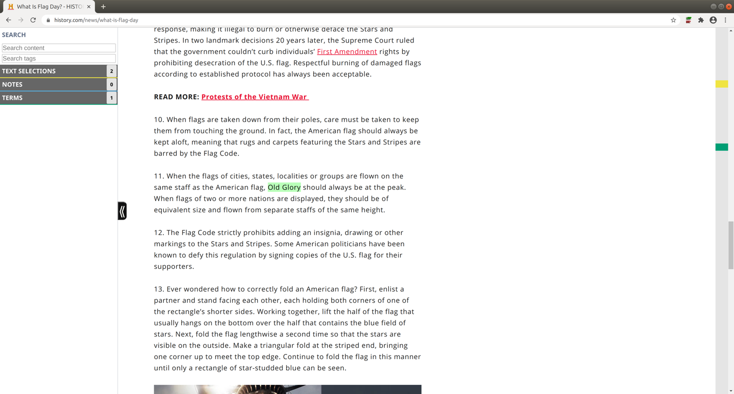

Artifacts created

Handle

Number of artifacts



Click to close

Click to open

Click to open

Click to open

Click to open

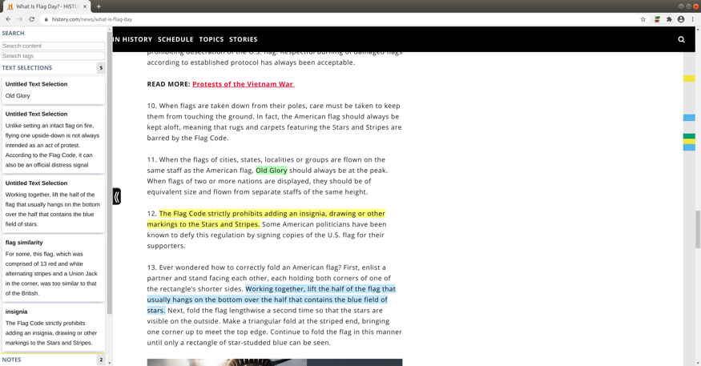

Term created

**Sidebar**

**Gutter**

Note created

Sidebar search

Selection created

Nubs

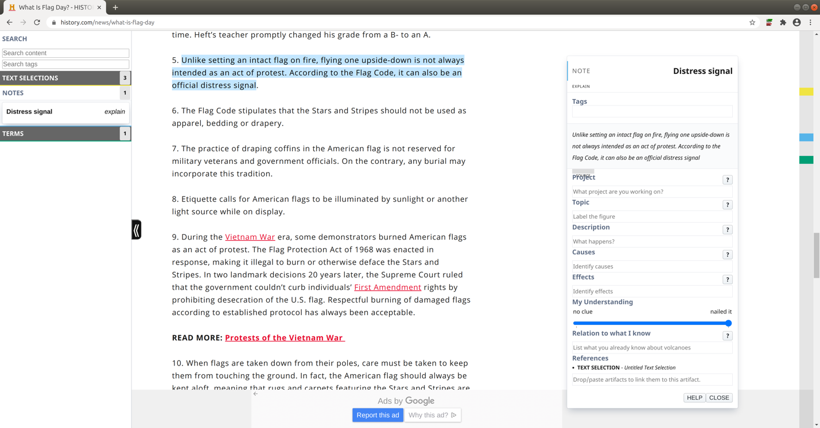

Click to open note

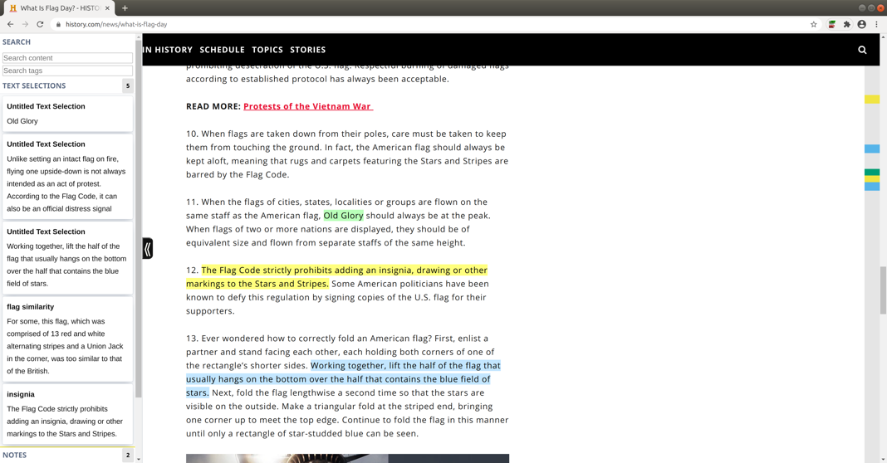

Yellow nub for selection

Blue nub for note

Green nub for term

This is a selection

Enter search word

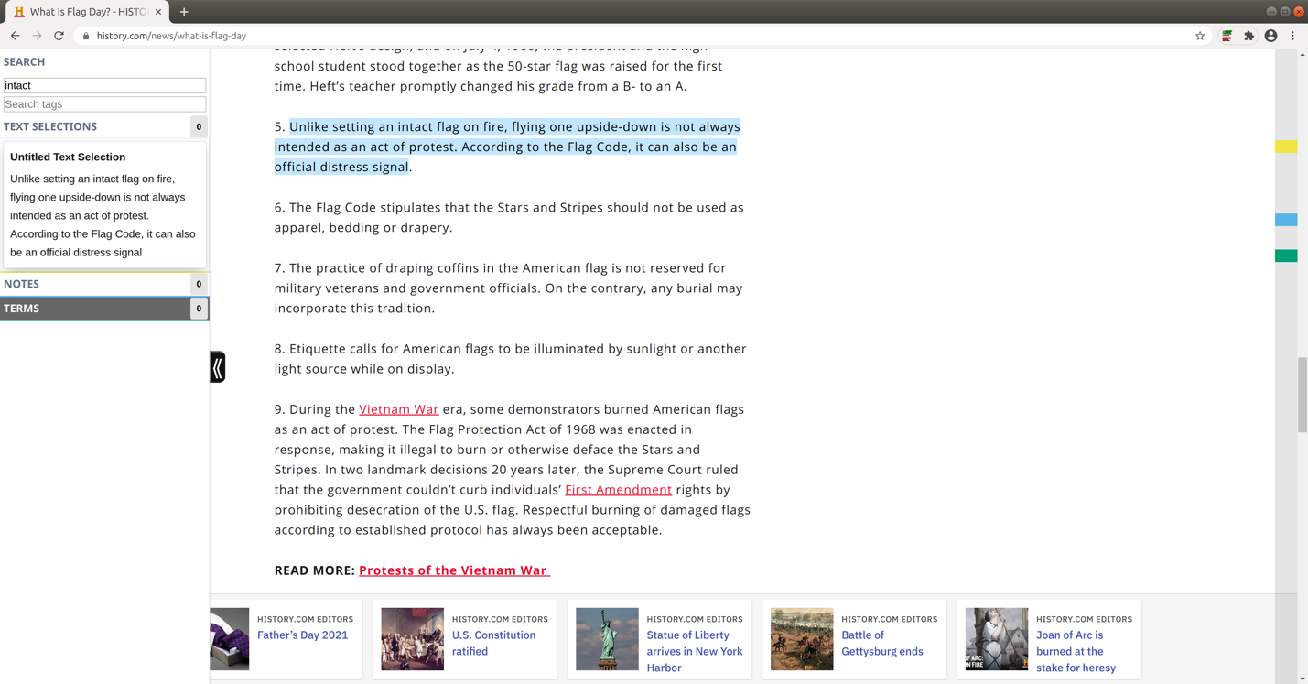

1

Click to open



1